
Daily Report

To join our research group on TELEGRAM, please click on the links - https://bit.ly/3JTeFcc and https://bit.ly/3TNuIgc

Friday, 21st Jun 2024
72.15.54

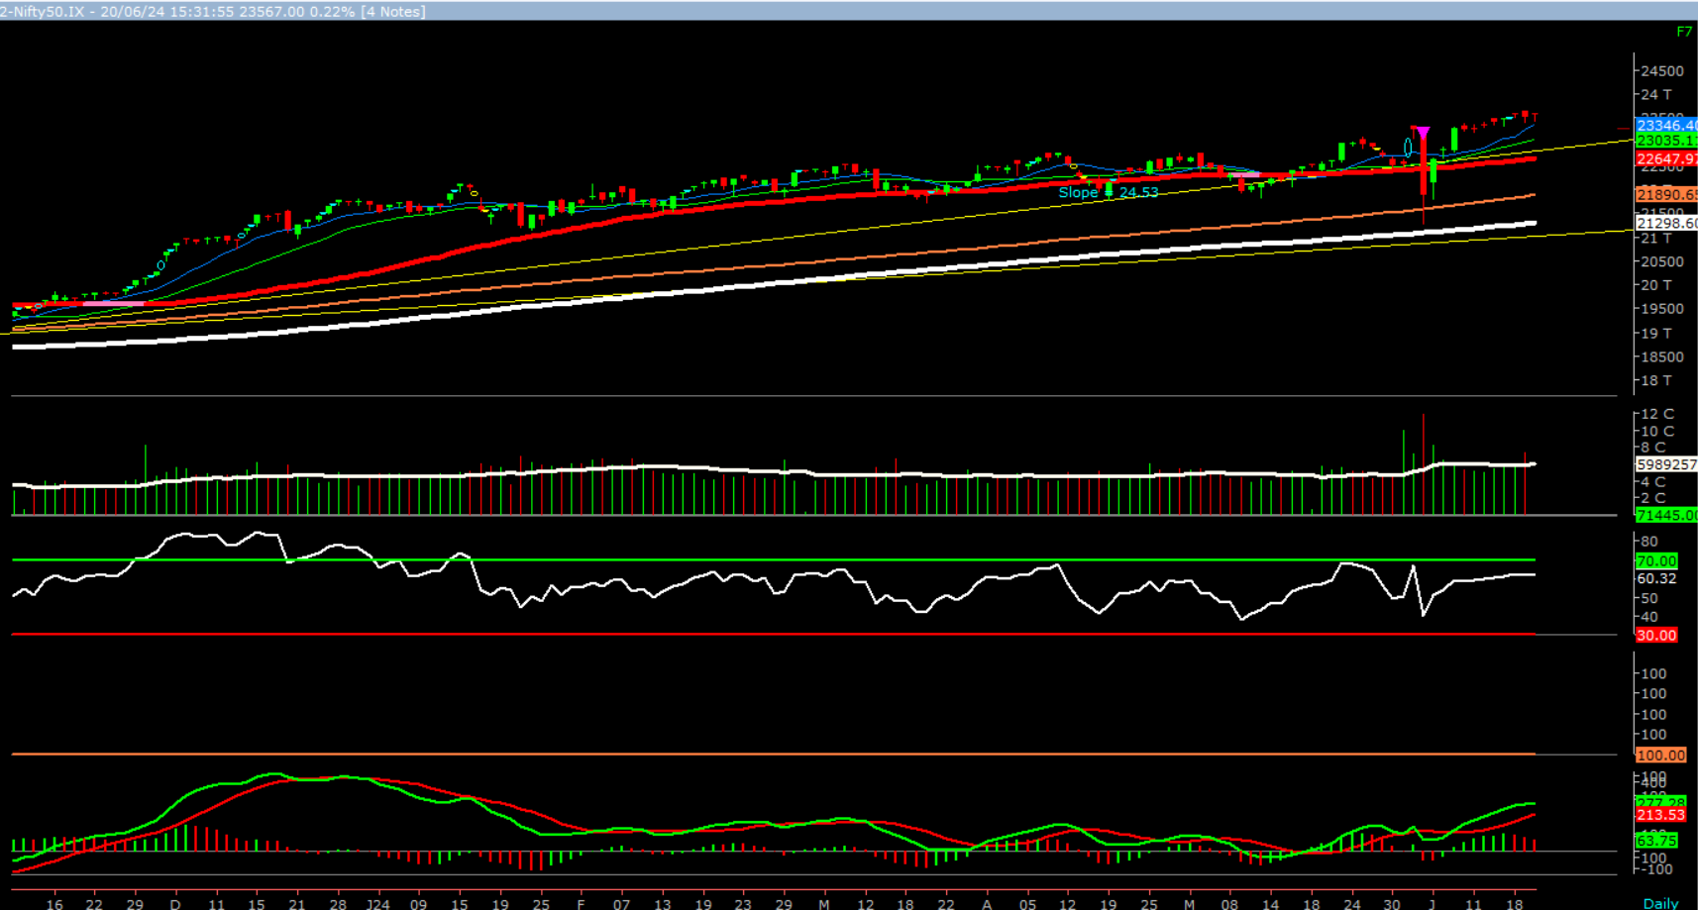  Source: Money Control (BSE 500) | Nifty opened higher, traded in a narrow range throughout the day to close in green. On the daily chart, we are observing eight consecutive narrow range body formation, which suggests that markets are circumspect at higher level. In coming trading session if nifty trades above 23630 level then it may test 23650 - 23740 levels. On the downside, 23450 - 23360 levels may act as support for the day.  We maintain our stance our stance that looking at the current price action, it is evident that a consolidation or minor pull back of prior uptrend could be possible. Hence, one can adopt cautiously positive approach at current level, as stock specific activity is likely to continue.
  Indian Indices | Last Price | (%) Chg
  NSE | 23567.00 | 0.22
  BSE | 77478.93 | 0.18
  World Indices | Last Price | (%) Chg
  Dow Jones | 39134.76 | 0.77
  Nasdaq | 17717.90 | -0.81
  Nikkei | 38616.00 | -0.08
  Hang Seng | 17966.50 | -1.29
  FTSE | 8272.46 | 0.82
  Commodity | Last Price | (%) Chg
  GOLD($/ounce) | 2372.95 | 0.17
  Silver ($/Ounce) | 30.57 | -0.79
  Crude ($/BBL) | 81.19 | -0.12
  Aluminium spot ($/mt) | 2524.00 | -0.08
  Copper SPOT ($/mt) | 9812.50 | -0.80
  Zinc ($/MT) | 2864.50 | -0.26
  Natural gas $/MMBtu | 2.72 | -0.15
  Currency | Last Price | (%) Chg
  USDINR | 83.61 | 0.24
  EURINR | 89.67 | -0.01
  Bond
  India 10 Yr Bond yield | 6.97 | 0.04
  52 Wk High |  |  | 52 Wk Low
  Company | Close Price | 52 | Company | Close Price | 52 Wk Low
  Company | Close Price | Wk High | Company | Close Price | 52 Wk Low
  ABCAPITAL | 243 | 247 | -- | -- | --
  BHARATFORG | 1790 | 1800 | -- | -- | --
  CHAMBLFERT | 558 | 561 | -- | -- | --
  EIXDEIND | 572 | 576 | -- | -- | --
  DIXON | 11498 | 11579 | -- | -- | --
  Market Technical Outlook
  Foreign Institutional Investments (FII's) Activities
  Name of Segment | Net Buyer/seller | Rs In Cr
  Index Futures | Net Buyer | 1739.69
  Stock Futures | Net Seller | -3174.74
  Net Future Position | Net Seller | -1435.05
  Index Options | Net Seller | -71333.35
  Stock Options | Net Buyer | 976.12
  Net Options Position | Net Seller | -70357.23
  FII In cash Segment | Net Buyer | 415.30
  DII In cash Segment | Net Seller | -325.81
  Net Cash Position | Net Buyer | 89.49

Guru Call: From the expert’s desk
Company | Reco Date | Reco Price (Buy on dips) | High till date | Return%
Adani Power | 20-Apr-22 | 235 | 345 | 46.6%
Adani Wilmar Ltd | 20-Apr-22 | 668 | 878 | 31.5%
Aditya Birla Capital Ltd | 13-Aug-21 | 124 | 139 | 12.5%
Aditya Birla Fashion and Retail Ltd | 8-Feb-21 | 164 | 322 | 95.9%
Apcotex Industries Limited | 13-Aug-21 | 343 | 679 | 98.0%
Asian Paints Ltd. | 30-Mar-17 | 1068 | 3590 | 236.1%
Avenue Supermarts Ltd. | 31-Jul-17 | 899 | 5900 | 556.6%
Axis Bank Ltd. | 10-Apr-18 | 519 | 867 | 67.0%
Bajaj Finance Ltd | 20-Apr-22 | 7033 | 7295 | 3.7%
Bajaj Finserv Ltd | 1-Nov-16 | 3417 | 19325 | 465.6%
Bajaj Holdings And Investment Ltd | 19-May-16 | 1499 | 6598 | 340.1%
CDSL | 17-Sep-20 | 486 | 1734 | 256.9%
Chola finance | 25-Sep-20 | 239 | 770 | 222.6%
Chola Holding | 23-Sep-20 | 392 | 763 | 94.7%
Cipla Ltd | 20-Mar-17 | 597 | 1083 | 81.3%
Colgate Palmolive | 16-Sep-19 | 1314 | 1823 | 38.7%
D. P. Abhushan Ltd | 20-Apr-22 | 396 | 495 | 25.0%
Dabur India | 22-Oct-19 | 466 | 659 | 41.4%
DLF Ltd | 10-Apr-19 | 194 | 450 | 131.6%
Dr Reddy | 4-Aug-20 | 4530 | 5615 | 24.0%
Emami Limited | 26-Jun-19 | 290 | 622 | 114.2%
Finolex Cables Ltd | 8-Feb-21 | 130 | 268 | 106.2%
Fortis | 14-Jul-20 | 127 | 314 | 147.2%
Godawari Power | 20-Apr-22 | 455 | 482 | 6.0%
Godrej Consumer Products Limited | 16-Jun-20 | 634 | 1138 | 79.5%
HDFC Asset Management Company Ltd. | 19-Dec-18 | 1573 | 3844 | 144.4%
HDFC Bank Limited | 10-Nov-16 | 639 | 1725 | 170.0%
HDFC Life Insurance Co Ltd | 19-Jan-18 | 485 | 776 | 60.0%
Heritage Foods Ltd | 20-Apr-22 | 330 | 354 | 7.2%
Hero Motocorp Ltd | 29-Sep-20 | 3175 | 3629 | 14.3%
Hindustan Unilever Ltd. | 13-Nov-17 | 1291 | 2859 | 121.5%
Housing Development Finance Corp Ltd | 19-Dec-17 | 1720 | 3365 | 95.6%
ICICI Bank Ltd. | 6-Apr-18 | 279 | 867 | 211.1%
ICICI Lombard General Insurance | 19-Sep-19 | 1155 | 1675 | 45.0%
ICICI Prudential Life Insurance Company Ltd. | 28-Jun-18 | 376 | 724 | 92.7%
ICICI Securities Ltd | 24-Sep-20 | 467 | 896 | 92.0%
Indusindbnk | 8-Jun-20 | 451 | 1242 | 175.4%
Infosys Ltd. | 17-Aug-17 | 488 | 1954 | 300.7%
Kotak Mahindra Bank Ltd | 10-Nov-16 | 822 | 2253 | 174.1%
Linde India | 20-Apr-22 | 3499 | 3649 | 4.3%
Marico Ltd. | 4-Apr-18 | 325 | 608 | 87.1%
Maruti Suzuki India Ltd | 13-Aug-20 | 5989 | 9050 | 51.1%
Oberoi Realty Ltd. | 23-Nov-17 | 509 | 1052 | 106.8%
PEL | 2-Sep-20 | 1246 | 3015 | 141.9%
Phoenix Mills Limited | 7-Jul-19 | 655 | 1200 | 83.2%
Poonawalla Fincorp Ltd | 13-Aug-21 | 175 | 344 | 96.1%
Procter & Gamble Hygiene & Health Care | 13-Aug-21 | 12870 | 16466 | 27.9%
Raymond | 25-Sep-20 | 264 | 1280 | 385.7%
Reliance | 22-Apr-20 | 1351 | 2856 | 111.4%
SBI Life | 20-May-20 | 715 | 1293 | 80.8%
Shree Renuka Sugars Limited | 13-Aug-21 | 27 | 63 | 135.1%
Spectrum Electrical | 18-Apr-22 | 98 | 103 | 5.0%

Guru Call: From the expert’s desk
Company | Reco Date | Reco Price (Buy on dips) | High till date | Return%
State Bank of India | 3-Feb-21 | 336 | 549 | 63.4%
Sun Pharma | 7-Aug-20 | 525 | 967 | 84.2%
Sun TV Network Ltd. | 13-Aug-21 | 525 | 612 | 16.5%
Tata Chemicals Limited | 24-Dec-19 | 297 | 1158 | 290.0%
Tata Consultancy Services Ltd. | 8-Jan-18 | 1345 | 4046 | 200.9%
Tata motors | 20-Apr-22 | 441 | 450 | 2.0%
Tata motors dvr | 20-Apr-22 | 220 | 226 | 2.6%
Tata Power | 20-Apr-22 | 249 | 260 | 4.4%
Trent Ltd. | 19-Dec-18 | 348 | 1347 | 286.6%
Ultratech Cement Ltd. | 19-Dec-18 | 4085 | 8269 | 102.4%
UTI Asset Management Company Ltd | 13-Aug-21 | 1044 | 1217 | 16.6%
Vedanta Ltd | 28-Jun-21 | 261 | 441 | 69.1%
Voltas Ltd. | 27-Mar-18 | 614 | 1357 | 121.0%
Whirlpool Of India Ltd. | 7-Dec-16 | 872 | 2550 | 192.3%
Wipro Limited | 13-Aug-21 | 616 | 740 | 20.2%

NIFTY 50 STOCKS BELOW 200SMA
SCRIP NAME | SMA 200 | CLOSING (20-06-2024)
ITC | 437.37 | 423.65
ASIANPAINT | 3046.47 | 2891.7
TITAN | 3481.94 | 3462.35
KOTAKBANK | 1758.84 | 1746.7
BAJAJFINSV | 1606.5 | 1594.9
LTIM | 5294.65 | 5019.85
HDFCLIFE | 616.43 | 596.2
-- | -- | --
-- | -- | --
-- | -- | --
-- | -- | --
-- | -- | --
-- | -- | --
-- | -- | --
-- | -- | --
-- | -- | --
-- | -- | --
-- | -- | --
-- | -- | --
-- | -- | --
-- | -- | --
-- | -- | --
-- | -- | --
-- | -- | --
-- | -- | --
-- | -- | --
-- | -- | --
-- | -- | --
-- | -- | --
-- | -- | --
-- | -- | --
-- | -- | --
-- | -- | --
-- | -- | --

Weekly Expiry Most Active Nifty Call Option
Symbol | Expiry Date | Strike Price | Highest Open Interest (Contracts)
NIFTY | 27-Jun-2024 | 24,000 | 3,53,353
NIFTY | 27-Jun-2024 | 25,000 | 2,90,004
NIFTY | 27-Jun-2024 | 23,500 | 1,82,629

Weekly Expiry Most Active Nifty Put Option
Symbol | Expiry Date | Strike Price | Highest Open Interest (Contracts)
NIFTY | 27-Jun-2024 | 23,000 | 3,37,384
NIFTY | 27-Jun-2024 | 22,500 | 3,17,243
NIFTY | 27-Jun-2024 | 22,000 | 2,67,747

Securities in Ban For Trade Date: 21-06-2024
BALRAMCHIN, BSOFT, GNFC, HAL, HINDCOPPER, INDUSTOWER, PEL
Bulk Deals (BSE)
N.A
Bulk Deals (NSE)
Deal Date | Scrip Name | Client Name | Deal Type | Quantity | Price
20-Jun-24 | HEUBACHIND | QUANT MUTUAL FUND | BUY | 120000 | 453.57
20-Jun-24 | IBREALEST | BOFA SECURITIES EUROPE SA | BUY | 3437792 | 154.92
20-Jun-24 | IBREALEST | EQUITY INTELLIGENCE INDIA PRIVATE LIMITED | BUY | 3300000 | 151.28
20-Jun-24 | PEL | ANUTHAM REALTY PRIVATE LIMITED | BUY | 10775000 | 906
20-Jun-24 | PNBHOUSING | MORGAN STANLEY ASIA SINGAPORE PTE - ODI | BUY | 2285810 | 785
20-Jun-24 | PNBHOUSING | BNP PARIBAS FINANCIAL MARKETS | BUY | 2862030 | 785
20-Jun-24 | PEL | THE SRIKRISHNA TRUST | SELL | 10775000 | 906
20-Jun-24 | PNBHOUSING | ASIA OPPORTUNITIES V (MAURITIUS) LIMITED | SELL | 6379030 | 786.46
20-Jun-24 | PNBHOUSING | GENERAL ATLANTIC SINGAPORE FUND FII PTE LTD | SELL | 6379030 | 787.88
20-Jun-24 | TCNSBRANDS | TA FDI INVESTORS LIMITED | SELL | 1800000 | 530.06
20-Jun-24 | WINDMACHIN | MC JAIN INFOSERVICES PRIVATE LIMITED | SELL | 400000 | 138.34

Note- Executed on 20th Jun 2024. Bulk Deal Buy/Sell done by fund house is considered.

Research Analyst Registration No. | Contact | Website | mail Id
INH000002764
INH000002764 | SMS: ‘Arihant’ to 56677 | www.arihantcapital.com | arihant.research@arihantcapital.com

Arihant is Forbes Asia’s ‘200 Best under a $Billion’ Company
‘Best Emerging Commodities Broker’ awarded by UTV Bloomberg
Disclaimer: This document has been prepared by Arihant Capital Markets Limited (hereinafter called as Arihant) and its subsidiaries and associated companies. This document does not constitute an offer or solicitation for the purchase and sale of any financial instrument by Arihant. Receipt and review of this document constitutes your agreement not to circulate, redistribute, retransmit or disclose to others the contents, opinions, conclusion, or information contained herein. This document has been prepared and issued on the basis of publicly available information, internally developed data and other sources believed to be reliable. Whilst meticulous care has been taken to ensure that the facts stated are accurate and opinions given are fair and reasonable, neither the analyst nor any employee of our company is in any way is responsible for its contents and nor is its accuracy or completeness guaranteed. This document is prepared for assistance only and is not intended to be and must not alone be taken as the basis for an investment decision. All recipients of this material should before dealing and or transacting in any of the products referred to in this material make their own investigation, seek appropriate professional advice. The investments discussed in this material may not be suitable for all investors. The recipient alone shall be fully responsible/are liable for any decision taken on the basis of this material. Arihant Capital Markets Ltd (including its affiliates) or its officers, directors, personnel and employees, including persons involved in the preparation or issuance of this material may; (a) from time to time, have positions in, and buy or sell or (b) be engaged in any other transaction and earn brokerage or other compensation in the financial instruments/products discussed herein or act as advisor or lender/borrower in respect of such securities/financial instruments/products or have other potential conflict of interest with respect to any recommendation and related information and opinions. The said persons may have acted upon and/or in a manner contradictory with the information contained here and may have a position or be otherwise interested in the investment referred to in this document before its publication. The user of this report assumes the entire risk of any use made of this data/report. Arihant especially states that it has no financial liability, whatsoever, to the users of this report.

Arihant Capital Markets Ltd
#1011 Solitaire Corporate Park Building No.10 1st Floor
Andheri Ghatkopar Link Road Chakala Andheri (E) Mumbai-400093
T. 022-42254800. Fax: 022-42254880
www.arihantcapital.com

