
Daily Report

Thursday, 28th Aug 2025
72.15.54

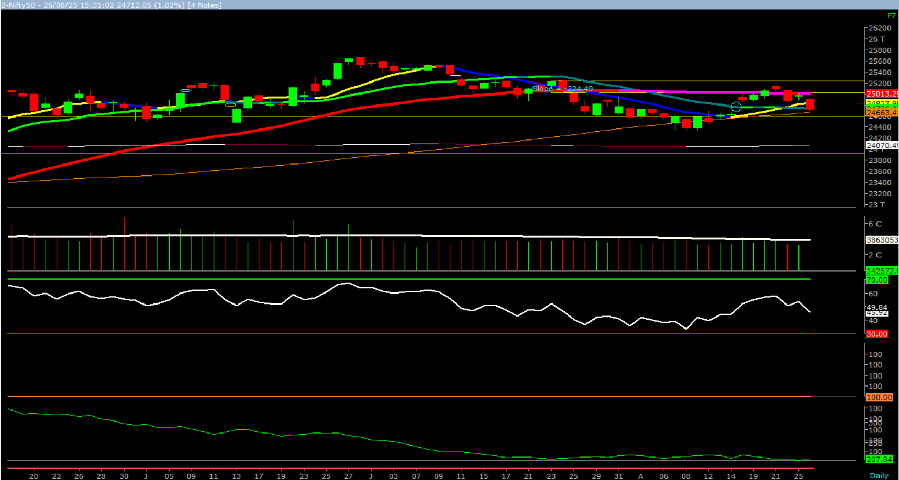  Source: Money Control (BSE 500) | The Nifty opened lower amid weak global cues, and downside momentum intensified as the session progressed, leading the index to close in red. On the daily chart, Nifty nearly tested the 100-day SMA (24,663) by making a low of 24,689. Thus, 24,663 emerges as a crucial support on a closing basis, and any sustained close below this level could trigger further selling pressure, dragging the index towards 24,600 – 24,500 levels. On the higher side, 24,800 – 24,910 levels are expected to act as resistance.  As highlighted earlier, the upward gap area in the range of 24,673 – 24,852 is likely to continue providing support to prices. Hence, traders are advised to maintain a cautiously positive stance at current levels, with a focus on selective stock-specific opportunities.
  Indian Indices | Last Price | (%) Chg
  NSE | 24712.05 | -1.02
  BSE | 80786.54 | -1.04
  World Indices | Last Price | (%) Chg
  Dow Jones | 45565.23 | 0.32
  Nasdaq | 21590.14 | 0.21
  Nikkei | 42731.74 | 0.50
  Hang Seng | 25053.43 | -0.59
  FTSE | 9255.50 | -0.11
  Commodity | Last Price | (%) Chg
  GOLD($/ounce) | 3446.05 | 0.37
  Silver ($/Ounce) | 38.89 | 0.54
  Crude ($/BBL) | 63.65 | -0.78
  Aluminium spot ($/mt) | 2605.40 | -1.24
  Copper SPOT ($/mt) | 9791.80 | 0.30
  Zinc ($/MT) | 2768.55 | 0.18
  Natural gas $/MMBtu | 2.87 | 0.03
  Currency | Last Price | (%) Chg
  USDINR | 87.52 | -0.13
  EURINR | 101.97 | -0.03
  Bond | Last Price | (%) Chg
  India 10 Yr Bond yield | 6.61 | 0.38
  52 Wk High |  |  | 52 Wk Low
  Company | Close Price | 52 | Company | Close Price | 52 Wk Low
  Company | Close Price | Wk High | Company | Close Price | 52 Wk Low
  AIIL | 3132 | 3187 | AAVAS | 1581 | 1562
  ECLERX | 4451 | 4639 | FIVESTAR | 561 | 558
  EICHERMOT | 6151 | 6212 | JINDALSAW | 197 | 197
  MARUTI | 14725 | 14823 | PETRONET | 268 | 268
  VMM | 153 | 157 | PRAJ | 400 | 397
  Market Technical Outlook
  Foreign Institutional Investments (FII's) Activities
  Name of Segment | Net Buyer/seller | Rs In Cr
  Index Futures | Net Seller | -1302.89
  Stock Futures | Net Buyer | 34.57
  Net Future Position | Net Seller | -1268.32
  Index Options | Net Buyer | 5110.99
  Stock Options | Net Seller | -47.96
  Net Options Position | Net Buyer | 5063.03
  FII In cash Segment | Net Seller | -6516.49
  DII In cash Segment | Net Buyer | 7060.37
  Net Cash Position | Net Buyer | 543.88

Guru Call: From the expert’s desk
Company | Reco Date | Reco Price (Buy on dips) | High till date | Return%
Aditya Birla Capital Ltd | 13-Aug-21 | 124 | 292 | 135.4%
Avenue Supermarts Ltd. | 31-Jul-17 | 899 | 5900 | 556.2%
Axis Bank Ltd. | 10-Apr-18 | 519 | 1339 | 157.9%
Bajaj Finance Ltd | 20-Apr-22 | 7033 | 9780 | 39.1%
Bajaj Finserv Ltd | 1-Nov-16 | 3417 | 21350 | 245.8%
Bajaj Holdings And Investment Ltd | 19-May-16 | 1499 | 14740 | 883.3%
CDSL | 17-Sep-20 | 486 | 1734 | 718.5%
Cipla Ltd | 20-Mar-17 | 597 | 1702 | 185.1%
Colgate Palmolive | 16-Sep-19 | 1314 | 3890 | 196.1%
D. P. Abhushan Ltd | 20-Apr-22 | 396 | 1927 | 386.6%
Dabur India | 22-Oct-19 | 466 | 672 | 44.2%
DLF Ltd | 10-Apr-19 | 194 | 967 | 398.4%
Dr Reddy | 4-Aug-20 | 4530 | 7105 | 56.8%
Emami Limited | 26-Jun-19 | 290 | 855 | 194.8%
Fortis | 14-Jul-20 | 127 | 971 | 664.5%
Godrej Consumer Products Limited | 16-Jun-20 | 634 | 1541 | 143.1%
HDFC Asset Management Company Ltd. | 19-Dec-18 | 1573 | 5869 | 273.1%
HDFC Bank Limited | 10-Nov-16 | 639 | 2037 | 218.7%
HDFC Life Insurance Co Ltd | 19-Jan-18 | 485 | 820 | 69.1%
Hero Motocorp Ltd | 29-Sep-20 | 3175 | 6246 | 96.7%
Hindustan Unilever Ltd. | 13-Nov-17 | 1291 | 3035 | 135.1%
ICICI Bank Ltd. | 6-Apr-18 | 279 | 1500 | 437.6%
ICICI Lombard General Insurance | 19-Sep-19 | 1155 | 2301 | 99.2%
ICICI Prudential Life Insurance Company Ltd. | 28-Jun-18 | 376 | 796 | 111.7%
Kotak Mahindra Bank Ltd | 10-Nov-16 | 822 | 2301 | 179.9%
Marico Ltd. | 4-Apr-18 | 325 | 745 | 129.2%
Maruti Suzuki India Ltd | 13-Aug-20 | 5989 | 14401 | 140.4%
NSDL | 07-Aug-25 | 900 | 1425 | 58.33%
Oberoi Realty Ltd. | 23-Nov-17 | 509 | 2343 | 360.3%
Phoenix Mills Limited | 7-Jul-19 | 655 | 2068 | 531.4%
Poonawalla Fincorp Ltd | 13-Aug-21 | 175 | 519 | 196.5%
Procter & Gamble Hygiene & Health Care | 13-Aug-21 | 12870 | 19250 | 49.5%
Reliance | 22-Apr-20 | 1351 | 3216 | 138.1%
SBI Life | 20-May-20 | 715 | 1936 | 170.8%
State Bank of India | 3-Feb-21 | 336 | 912 | 171.4%
Tata motors | 20-Apr-22 | 441 | 1179 | 167.3%
Trent Ltd. | 19-Dec-18 | 348 | 8345 | 2297.9%
Ultratech Cement Ltd. | 19-Dec-18 | 4085 | 12714 | 211.2%
UTI Asset Management Company Ltd | 13-Aug-21 | 1044 | 1494 | 43.1%
Voltas Ltd. | 27-Mar-18 | 614 | 1944 | 216.6%
Whirlpool Of India Ltd. | 7-Dec-16 | 872 | 2787 | 219.6%

Securities in Ban For Trade Date: 28-08-2025
RBLBANK

NIFTY 50 STOCKS BELOW 200SMA
SCRIP NAME | SMA 200 | CLOSING (26-08-2025)
INFY | 1684.33 | 1529.6
WIPRO | 273.42 | 252.03
ITC | 425.31 | 403.35
HCLTECH | 1679.59 | 1492.8
TATAMOTORS | 706 | 681.65
ADANIENT | 2425.83 | 2272
SUNPHARMA | 1725.47 | 1600.3
AXISBANK | 1109.1 | 1050.1
ONGC | 244.75 | 234.19
TRENT | 5741.21 | 5295
INDUSINDBK | 879.09 | 756.4
SHRIRAMFIN | 621.47 | 594.7
POWERGRID | 296.42 | 279.9
TCS | 3672.02 | 3157.2
KOTAKBANK | 1987.36 | 1965.7
TECHM | 1590.72 | 1502.2
NTPC | 340.2 | 333.2
COALINDIA | 389.62 | 372.45
-- | -- | --
-- | -- | --
-- | -- | --
-- | -- | --
-- | -- | --
-- | -- | --
-- | -- | --
-- | -- | --
-- | -- | --
-- | -- | --
-- | -- | --
-- | -- | --
-- | -- | --
-- | -- | --
-- | -- | --
-- | -- | --
-- | -- | --
-- | -- | --

Weekly Expiry Most Active Nifty Call Option
Symbol | Expiry Date | Strike Price | Highest Open Interest (Contracts)
NIFTY | 28-Aug-2025 | 25,000 | 2,35,430
NIFTY | 28-Aug-2025 | 24,800 | 1,57,243
NIFTY | 28-Aug-2025 | 25,200 | 1,52,680

Weekly Expiry Most Active Nifty Put Option
Symbol | Expiry Date | Strike Price | Highest Open Interest (Contracts)
NIFTY | 28-Aug-2025 | 24,000 | 1,26,063
NIFTY | 28-Aug-2025 | 24,500 | 1,05,756
NIFTY | 28-Aug-2025 | 24,700 | 90,722

Bulk Deals (BSE)
N.A

Bulk Deals (NSE)
Deal Date | Scrip Name | Client Name | Deal Type | Quantity | Price
26-Aug-25 | EDELWEISS | ABAKKUS ASSET MANAGER PRIVATE LIMITED | BUY | 6430780 | 100
26-Aug-25 | ETERNAL | BNP PARIBAS FINANCIAL MARKETS | BUY | 101239655 | 318.1
26-Aug-25 | SAILIFE | GOLDMAN SACHS (SINGAPORE) PTE | BUY | 1104008 | 871.05
26-Aug-25 | SAILIFE | SOCIETE GENERALE | BUY | 1406922 | 871
26-Aug-25 | SAMMAANCAP | PLUTUS WEALTH MANAGEMENT LLP | BUY | 4250000 | 119.69
26-Aug-25 | SONACOMS | INTEGRATED CORE STRATEGIES (ASIA) PTE. LTD. | BUY | 10439130 | 454.51
26-Aug-25 | SWIGGY | SOCIETE GENERALE | BUY | 125767 | 426.52
26-Aug-25 | SWIGGY | BNP PARIBAS FINANCIAL MARKETS | BUY | 434660 | 426.68
26-Aug-25 | VERANDA | AUTHUM INVESTMENT & INFRASTRUCTURE LIMITED | BUY | 5800000 | 230.1
26-Aug-25 | VERANDA | GOLDMAN SACHS (SINGAPORE) PTE | BUY | 760870 | 229.95
26-Aug-25 | VIKRAMSOLR | PLUTUS WEALTH MANAGEMENT LLP | BUY | 2000000 | 352.33
26-Aug-25 | ARISINFRA | NECTA BLOOM VCC - REGAL FUND | SELL | 450000 | 148.21
26-Aug-25 | EDELWEISS | EDELWEISS EMPLOYEES INCENTIVES AND WELFARE TRUST | SELL | 5301510 | 100
26-Aug-25 | ETERNAL | BNP PARIBAS FINANCIAL MARKETS | SELL | 16083 | 317.94
26-Aug-25 | POWERINDIA | BNP PARIBAS FINANCIAL MARKETS | SELL | 419164 | 19794.72
26-Aug-25 | SAILIFE | TPG ASIA VII SF PTE LTD | SELL | 10235611 | 871.86
26-Aug-25 | SAILIFE | TPG ASIA VII SF PTE LTD | SELL | 10235611 | 871.18
26-Aug-25 | SAILIFE | TPG ASIA VII SF PTE LTD | SELL | 10235611 | 871.01
26-Aug-25 | SWIGGY | BNP PARIBAS FINANCIAL MARKETS | SELL | 26902006 | 430.38
26-Aug-25 | SWIGGY | SOCIETE GENERALE | SELL | 14253674 | 429.97
26-Aug-25 | VMM | BNP PARIBAS FINANCIAL MARKETS | SELL | 55309783 | 152.8
26-Aug-25 | VMM | INTEGRATED CORE STRATEGIES (ASIA) PTE. LTD. | SELL | 24126740 | 152.64
26-Aug-25 | WAAREEENER | BNP PARIBAS FINANCIAL MARKETS | SELL | 1783703 | 3266.21

Note- Executed on 26th Aug 2025. Bulk Deal Buy/Sell done by fund house is considered.

Research Analyst Registration No. | Contact | Website | mail Id
INH000002764
INH000002764 | SMS: ‘Arihant’ to 56677 | www.arihantcapital.com | arihant.research@arihantcapital.com

Arihant is Forbes Asia’s ‘200 Best under a $Billion’ Company
‘Best Emerging Commodities Broker’ awarded by UTV Bloomberg
Disclaimer: This document has been prepared by Arihant Capital Markets Limited (hereinafter called as Arihant) and its subsidiaries and associated companies. This document does not constitute an offer or solicitation for the purchase and sale of any financial instrument by Arihant. Receipt and review of this document constitutes your agreement not to circulate, redistribute, retransmit or disclose to others the contents, opinions, conclusion, or information contained herein. This document has been prepared and issued on the basis of publicly available information, internally developed data and other sources believed to be reliable. Whilst meticulous care has been taken to ensure that the facts stated are accurate and opinions given are fair and reasonable, neither the analyst nor any employee of our company is in any way is responsible for its contents and nor is its accuracy or completeness guaranteed. This document is prepared for assistance only and is not intended to be and must not alone be taken as the basis for an investment decision. All recipients of this material should before dealing and or transacting in any of the products referred to in this material make their own investigation, seek appropriate professional advice. The investments discussed in this material may not be suitable for all investors. The recipient alone shall be fully responsible/are liable for any decision taken on the basis of this material. Arihant Capital Markets Ltd (including its affiliates) or its officers, directors, personnel and employees, including persons involved in the preparation or issuance of this material may; (a) from time to time, have positions in, and buy or sell or (b) be engaged in any other transaction and earn brokerage or other compensation in the financial instruments/products discussed herein or act as advisor or lender/borrower in respect of such securities/financial instruments/products or have other potential conflict of interest with respect to any recommendation and related information and opinions. The said persons may have acted upon and/or in a manner contradictory with the information contained here and may have a position or be otherwise interested in the investment referred to in this document before its publication. The user of this report assumes the entire risk of any use made of this data/report. Arihant especially states that it has no financial liability, whatsoever, to the users of this report.

Arihant Capital Markets Ltd
#1011 Solitaire Corporate Park Building No.10 1st Floor
Andheri Ghatkopar Link Road Chakala Andheri (E) Mumbai-400093
T. 022-42254800. Fax: 022-42254880
www.arihantcapital.com

