01.09.25

APOLLO=262

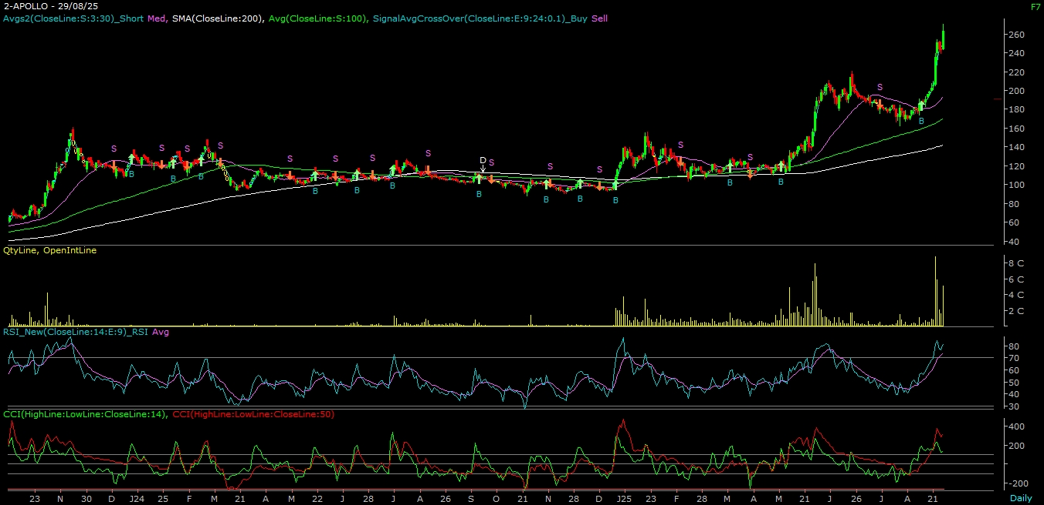

ABOUT THE COMPANY

Apollo Micro Systems Ltd is a distinguished leader in the design, development, assembly, and testing of electronic and electromechanical solutions. As a prominent player in India, the company excels in providing a wide range of electronic, electromechanical, and engineering design and manufacturing services. Their comprehensive offerings include Electronic Manufacturing Services (EMS), PCB fabrication, embedded software design and development, circuit board assembly, hardware design services, concept-to-product development, host interface development, and customized electronic systems.

TECHNICAL VIEW

APOLLO | CMP= ₹ 262 | Stop loss ₹ 220 | Tgt1: ₹ 360 | Tgt2: ₹ 450

On the daily chart, we are observing a “Rounding formation” breakout with good volume activity & prices trading above all the key Moving averages lines. On the weekly chart, we are observing “Flag” pattern formation. Apart from that, the stock also outperformed in the falling market. Further, the momentum indicator, viz. MACD is positively poised. Combining the above parameters, it is evident that momentum on the upside is likely to continue. Hence, one can buy the stock at CMP = 262 or decline up to 240 with a stop loss of ₹ 220 for a target of ₹ 360 – ₹ 450 levels in mid-term.

