03.11.25

BSE=2479

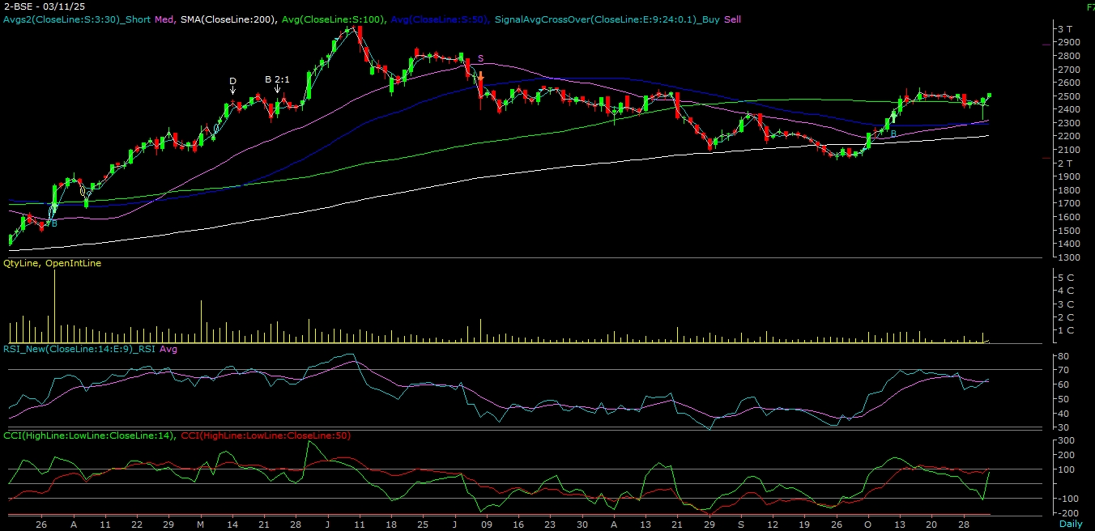

ABOUT THE COMPANY

The Bombay Stock Exchange (BSE Ltd), located on Dalal Street in Mumbai, is an Indian stock exchange for trading equities, currencies, debt instruments, derivatives, and mutual funds. Established in 1875, it was the first stock exchange in Asia and gained permanent recognition under Indian law.

TECHNICAL VIEW

BSE | CMP= ₹ 2479 | Stop loss ₹ 2300 | Tgt1: ₹ 2750 | Tgt2: ₹ 2850

On the daily chart, we are observing “HAMMER” candlestick formation & prices trading above all the key Moving averages lines. On the weekly chart, we are observing a “downward-sloping trendline” breakout. Apart from that, the stock also outperformed in the falling market. Further, the momentum indicator, viz. MACD is positively poised. Combining the above parameters, it is evident that momentum on the upside is likely to continue. Hence, one can buy the stock at CMP = 2479 or decline up to 2390 with a stop loss of ₹ 2300 for a target of ₹ 2750 – ₹ 2850 levels in mid-term.

