Nifty Technical Outlook (SEPT - 2025) CMP = 24426.85
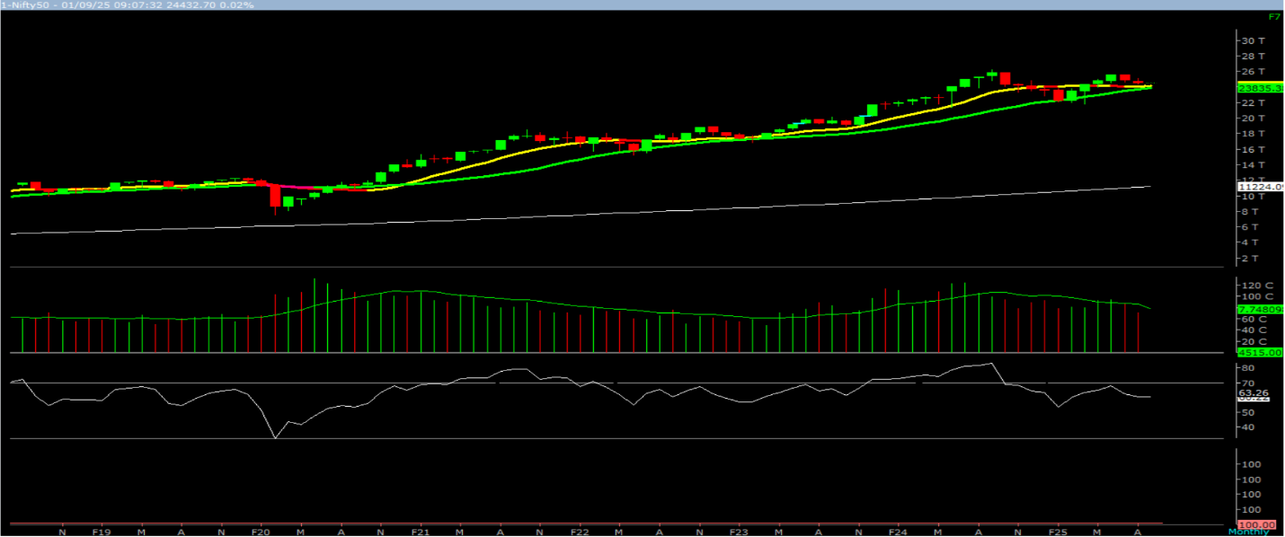

On the monthly chart, we are witnessing a pullback of the previous up move, with the current candle forming a “Doji” candlestick pattern. This indicates that the preceding rally is losing momentum.
In the coming month, if Nifty trades and sustains above 24,591, it could extend its gains toward 24829 – 25067 – 25345 zones. Conversely, a trade and close below 24,261 may trigger a corrective move toward 24023 – 23785 - 23507 levels.
Broadly, the current price structure suggests a high probability that prices may find support in the 24,500 – 24,273 zone, from where buying interest could emerge, potentially propelling Nifty toward the 24829 – 25067 – 25345 levels. Hence, a cautiously positive approach is advisable at current levels.

